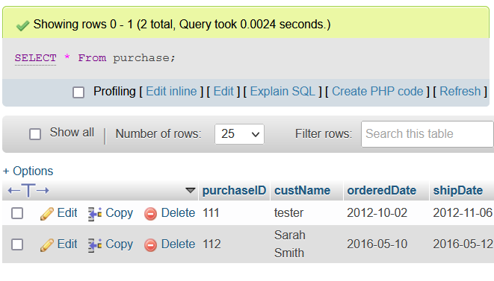

It will be best to write LAST_INSERT_ID() there in place of the question mark as then it will take the forward key of the last created purchaseID value (as it has been auto-incremented) in the same transaction and use it to make the id in the child table.

since it said to commit, I am following the assumption of adding the records to the parent and child table before commiting it. Thus my command:

INSERT into Purchase (custName, shipDate, orderedDate) VALUES ('Sarah

Smith', '2016-05-12', '2016-05-10');

Insert into PurchasedItem (purchaseID, itemNo, productName, orderedqty,

quotedPrice) VALUES (LAST_INSERT_ID(), 1, 'Cricket bat', 2, 80.50);

commit;

(please see next page for screenshot)

screenshot:

